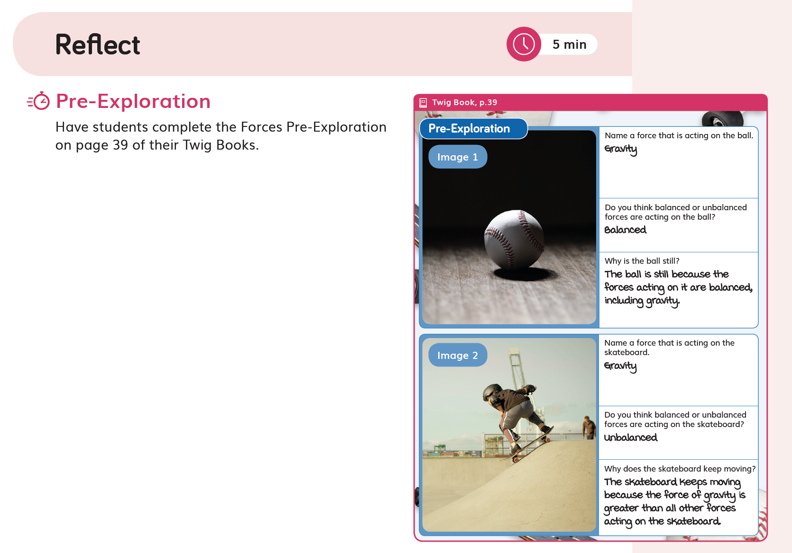
Introduction to Assessment

The Twig Science Assessment System has been developed in partnership with Stanford University’s SCALE team. It is designed to provide a three-dimensional assessment system that allows teachers to evaluate student attainment of the three dimensions and Performance Expectations (PEs) of the NGSS.

The assessment strategies measure students’ knowledge and ability. They favor Performance Tasks over rote memorization and include a rich variety of measures, such as written assignments, collaborative engineering design challenges, and oral presentations. There are also lots of informal ways to quickly evaluate student progress.

Full details of the assessment opportunities in each module are provided in the Module Assessment Overviews.
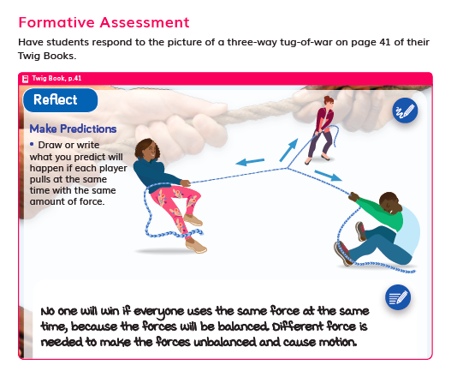

Pre-Explorations (Diagnostic Pre-Assessment)

Near the start of each module, students complete a Pre-Exploration (Diagnostic Pre-Assessment). Pre-Explorations enable teachers to identify student prior knowledge and misconceptions. Progress Trackers support teachers to track how students address their misconceptions as they gain new understanding. Additional Pre-Explorations are integrated at strategic points throughout the module where they add most value.

Formative Assessments (Informal Assessment)

Ongoing Formative Assessment, sometimes referred to as Informal Assessments, are woven into each lesson. These are quick way to gauge student understanding, allowing teachers to tailor their instruction accordingly. They include class discussions, constructed responses (written and drawn), self and peer assessment, and teacher observations.

Summative Assessments

Summative Performance Tasks are rich and highly engaging activities designed to motivate students to show off their attainment level of the module PEs. Rubrics support easy grading. Leveled rubrics are provided from Grade 2 Grade 2 onwards to give students a clear understanding of what success looks like.

Modules in Grades 3–6 include SCALE Benchmark Assessments, which assess students’ ability to apply the knowledge and skills gained throughout the module to new contexts. This gives students exposure to the types of assessment items they will face in the state test. Leveled rubrics support easy grading with sample student answers provided in the form of “Look Fors.” Student versions of these rubrics are available without the “Look Fors.”

Grades 3–6 also include 3-D Multiple Choice Assessments, which quickly assess student understanding of a range of dimensions covered in the module. An extended section (Part C) has been designed to stretch GATE students.

In this Program-Level Student Progress Rubric, examples of assessment items have been cited from Grade 1 Module 1, Grade 3 Module 3, and Grade 4 Module 4 to provide a sample of the breadth and quality of the assessment items over all of K–6. Module-level rubrics are also available..

Museum of Leafology Assessment Story

In this module students figure out the Module Phenomenon: How are all plants alike and how are they different? Through a series of hands-on and data investigations, and nature explorations, including growing plants from seed, students gain understanding of the different parts of plants and their shapes and functions. At the same time, they develop valuable skills in making observations and comparisons, and identifying patterns.

Students investigate what plants need and how a plant’s parts help it to grow and survive. They go on to explore the many methods that plants use to distribute seeds away from the parent plant. Students work in teams to tackle their first Engineering Design Challenge: to design and build seeds for dispersal by wind. They test and present the results of their design before adding a Seeds Room to the Museum of Leafology.

Students observe the seedlings they planted, as well as plants in nature, and record similarities and differences. They also investigate the clever strategies plants use to get what they need, including defences that some plants use. After observing and discussing existing inventions that were inspired by plants, students tackle their second Engineering Design Challenge to design, build, and present their own plant-inspired solution to a human problem.

At the end of the module, students invite other classes and their own families to visit the museum in order to demonstrate their learning. The final lesson features a pair of assessment tasks and a reading about edible plants, followed by a celebratory plant parts salad.

The Ultimate Playground Assessment Story

In this module students figure out the Module Phenomenon: How are objects affected by the forces of push and pull? Through a series of investigations, students observe and explain how push and pull forces affect the motion of objects, such as playground equipment, dumbbells, and soccer balls. They plan and carry out investigations to figure out how balanced and unbalanced forces affect objects, how several forces can act upon a stationary object, and work like engineers to test roller coaster cars.

Students develop and use models to collect and analyze data, and identify patterns that help them to predict a swing’s motion. They then explore non-contact forces, focusing on magnetic forces.

In the final Performance Task, students design, build, test and refine a Dragon Ride for their Ultimate Playground, using magnets to solve the problem of how the ride will be exciting and fun. Students are assessed on their ability to evaluate multiple design solutions, and ensuring that the final design meets criteria and constraints.

Earthquake Engineering Assessment Story

In this module, students solve the investigative problem: How do we reduce the damage caused by earthquakes. Using an interactive map, students make sense of why earthquakes appear in patterns along plate boundaries and how those patterns help earthquake engineers plan how and where to build. Students are assessed on their ability to analyze data in maps, to identify Earth's features, and identify patterns where earthquakes occur.

Through a series of investigations, students build understanding of how the shape, structure, and properties of materials affect buildings’ ability to withstand forces. They use this knowledge to design, build, and test their first earthquake-resistant structures. Students continue to make observations and obtain information from physical models, informational texts, and videos, which informs their design revisions

In the final presentation of their engineering designs, students explain how decisions about building characteristics, such as materials’ flexibility, shape, and symmetry), address the Module Investigative Problem. Students are assessed on their ability to evaluate multiple design solutions for make buildings more earthquake-resistant, and ensuring the solutions meet the design criteria and constraints.

Designed for the NGSS: Student Progress Rubric
Evidence Chart

Directions
- Review your assigned materials to identify assessments of and for learning. Complete an evidence chart for each identified assessment.
- Respond to the prompts or answer the questions in the space provided.
- Be prepared to represent your responses visually on a public chart.

Pre-Explorations

Assessment Description
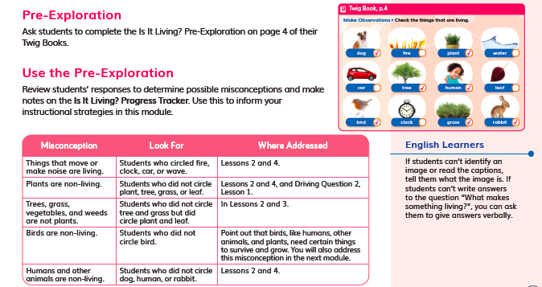  Grade 1 Module 1 DQ1L1 Reflect TE p.11/DQ1L1 TB p.4 | Describe the assessment (e.g., how many questions, presence of tables/charts, graphs) | Purpose of Assessment  (i.e., peer, self, formative, summative, per/post) | Type of Measure (e.g., performance task, discussion, multiple choice. constructed response) | Note evidence of bias or problems with accessibility
 | Students look at 12 images and check those that show things that are living. | Prior knowledge/ Pre-assessment | Constructed response  Multiple choice | No evidence of bias
Match among Assessment, Phenomena/Problem, and Three Dimensions
What phenomenon or problem, if any, are students trying to figure out in this assessment? |  | What is the 2-3 dimensional learning goal assessed in this task?
Students figure out which images show living things. |  | Students are assessed on their prior knowledge of living and non-living things.

Assessment Description
Grade 3 Module 1 DQ2L1 Reflect TE p.119/  DQ2L1 Reflect TB p.39 | Describe the assessment (e.g., how many questions, presence of tables/charts, graphs). | Purpose of Assessment  (i.e., peer, self, formative, summative, per/post) | Type of Measure (e.g., performance task, discussion, multiple choice. constructed response) | Note evidence of bias or problems with accessibility.
 | Students observe two images and identify the forces acting on objects, then state whether they are balanced or unbalanced. | Pre-assessment | Images with written response | No evidence of bias
Match among Assessment, Phenomena/Problem, and Three Dimensions
What phenomenon or problem, if any, are students trying to figure out in this assessment? |  | What is the 2-3 dimensional learning goal assessed in this task?
Students use prior knowledge to work out whether balanced or unbalanced forces are affecting the motion of a skateboarder, and a stationary baseball. |  | Students are pre-assessed on their knowledge of push and pull forces, and the effects of balanced and unbalanced forces on objects’ motion. They apply the concept of cause-and-effect to construct their responses. (PS2.A, PS2.B, CCC-2)

Assessment Description
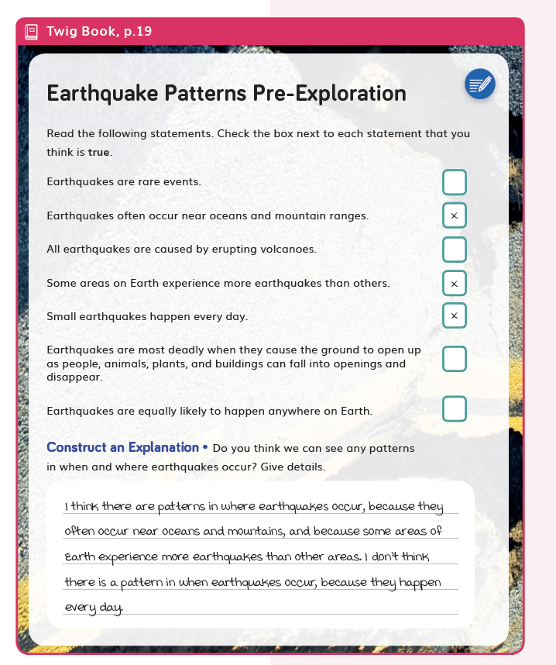  Grade 4 Module 4 DQ1L5 Reflect TE p. 41/DQ1L5 Reflect TB p. 19 | Describe the assessment (e.g., how many questions, presence of tables/charts, graphs). | Purpose of Assessment  (i.e., peer, self, formative, summative, per/post) | Type of Measure (e.g., performance task, discussion, multiple choice. constructed response) | Note evidence of bias or problems with accessibility.
 | Students read seven statements about earthquake and decide if they are true or false. Then, answer a question about patterns. | Pre-assessment | Multiple choice and constructed response | No evidence of bias. Text- to-speech function available for students that require language support
Match among Assessment, Phenomena/Problem, and Three Dimensions
What phenomenon or problem, if any, are students trying to figure out in this assessment? |  | What is the 2-3 dimensional learning goal assessed in this task?
Students are assessing their prior knowledge/misconceptions of the phenomenon of earthquakes. |  | There is no learning goal assessed in this pre-assessment. It is assessing prior knowledge of ESS2-B and CCC-1.

Formative Assessment (Informal Assessment)

Assessment Description
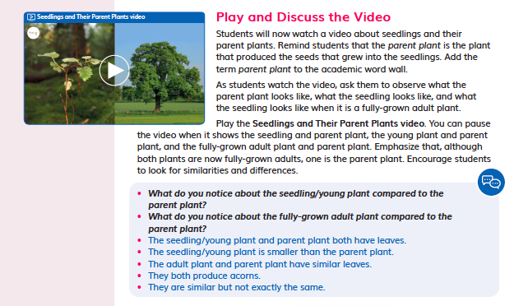Grade 1 Module 1 DQ4L4 Spark TE p. 150 | Describe the assessment (e.g., how many questions, presence of tables/charts, graphs). | Purpose of Assessment  (i.e., peer, self, formative, summative, per/post) | Type of Measure (e.g., performance task, discussion, multiple choice. constructed response) | Note evidence of bias or problems with accessibility.
 | Students watch and video, then have a class discussion. | Formative | Discussion | No evidence of bias
Match among Assessment, Phenomena/Problem, and Three Dimensions
What phenomenon or problem, if any, are students trying to figure out in this assessment? |  | What is the 2-3 dimensional learning goal assessed in this task?
Students observe seedlings and parent plants, then discuss the module phenomenon—How are plants alike and how are they different? |  | Students are assessed on their ability to make observations from watching a video, and explain ideas in a class discussion. They should be able to communicate how plant offspring look alike, and look different to their parent plants.

Assessment Description
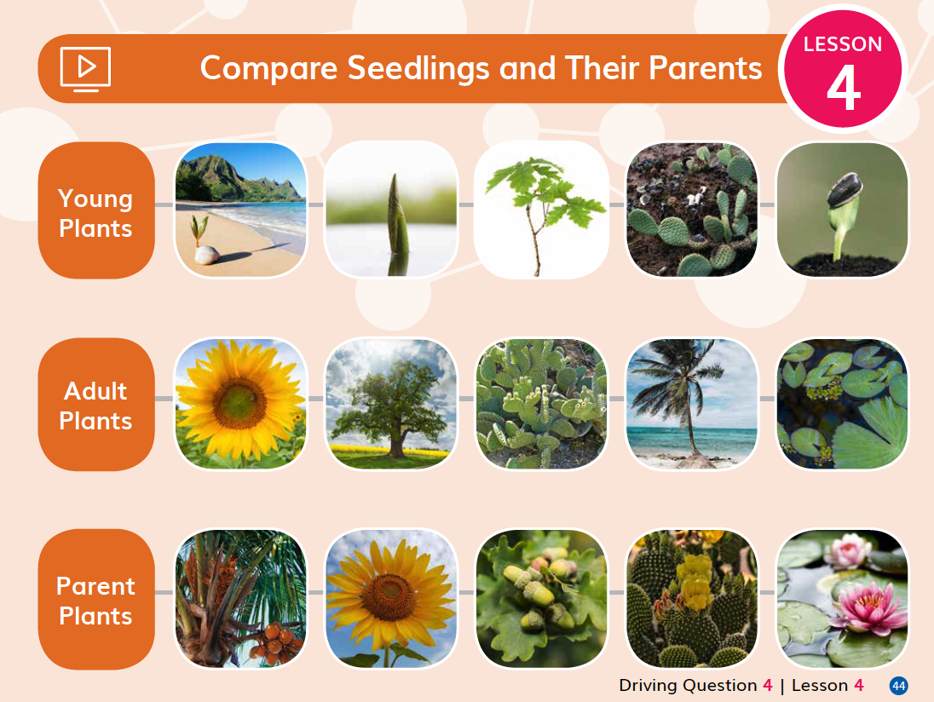Grade 1 Module 1 DQ4L4 Spark TE p. 150/DQ4L4 TB p. 44 | Describe the assessment (e.g., how many questions, presence of tables/charts, graphs). | Purpose of Assessment  (i.e., peer, self, formative, summative, per/post) | Type of Measure (e.g., performance task, discussion, multiple choice. constructed response) | Note evidence of bias or problems with accessibility.
 | A table of images showing a row of Young Plants, Adult Plants, and Parent Plants. Students connect the Young Plant images to how they will look as Adult Plants, and then to their Parent Plants. | Peer, self | Constructed response, matching/sorting images, discussion | No evidence of bias
Match among Assessment, Phenomena/Problem, and Three Dimensions
What phenomenon or problem, if any, are students trying to figure out in this assessment? |  | What is the 2-3 dimensional learning goal assessed in this task?
Students work with a partner to match young plants to their parent plants, and then discuss the reasons for their answers. |  | Students are assessed on their ability to recognize and match young plants to their parent plants, and to explain their reasoning to a peer based on evidence of how they are alike and different.

Assessment Description
Grade 3 Module 1 DQ2L2 Reflect TE p. 129/DQ2L2 Reflect TB p. 41 | Describe the assessment (e.g., how many questions, presence of tables/charts, graphs). | Purpose of Assessment  (i.e., peer, self, formative, summative, per/post) | Type of Measure (e.g., performance task, discussion, multiple choice. constructed response) | Note evidence of bias or problems with accessibility.
 | One prompt asking students to make a prediction about the outcome of a game of tug-of-war. Students annotate a diagram or write what they think will happen. | Formative | Constructed written response | No evidence of bias. Text-to-speech function. The assessment can be completed by either annotating a diagram to show the forces and motion or causes and effects, or by writing a statement
Match among Assessment, Phenomena/Problem, and Three Dimensions
What phenomenon or problem, if any, are students trying to figure out in this assessment? |  | What is the 2-3 dimensional learning goal assessed in this task?
Students are asked to predict the effects balanced forces will have on the motion of a tug-of-war rope. |  | Students are assessed on their understanding of balanced and unbalanced forces (PS2.A) and the cause-and-effect relationship (CCC-2) between forces and motion. Students demonstrate their understanding by annotating a model (SEP-2) or constructing a statement based on evidence and reasoning (SEP-8).

Assessment Description
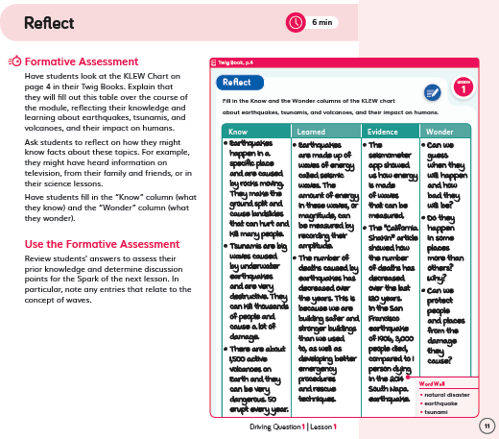  Grade 4 Module 4 DQ1L1 Reflect TE p. 11/DQ1L1 Reflect TB p. 4 | Describe the assessment (e.g., how many questions, presence of tables/charts, graphs). | Purpose of Assessment  (i.e., peer, self, formative, summative, per/post) | Type of Measure (e.g., performance task, discussion, multiple choice. constructed response) | Note evidence of bias or problems with accessibility.
 | Students fill in a KLEW chart (Know, Learned, Evidence, Wonder) to reflect on what they already know about natural disasters and what they wonder  about. | Self | Constructed written response | No evidence of bias. All students able to self-reflect. Text-to-speech function available for students that require language support
Match among Assessment, Phenomena/Problem, and Three Dimensions
What phenomenon or problem, if any, are students trying to figure out in this assessment? |  | What is the 2-3 dimensional learning goal assessed in this task?
Students are assessing their prior knowledge of earthquakes, tsunamis, and volcanoes, and the problem of their impact on humans. |  | Students are defining the problem (SEP-1 ) of natural hazards (ESS3B) and how earthquakes can change landscapes (CCC-7).

Assessment Description
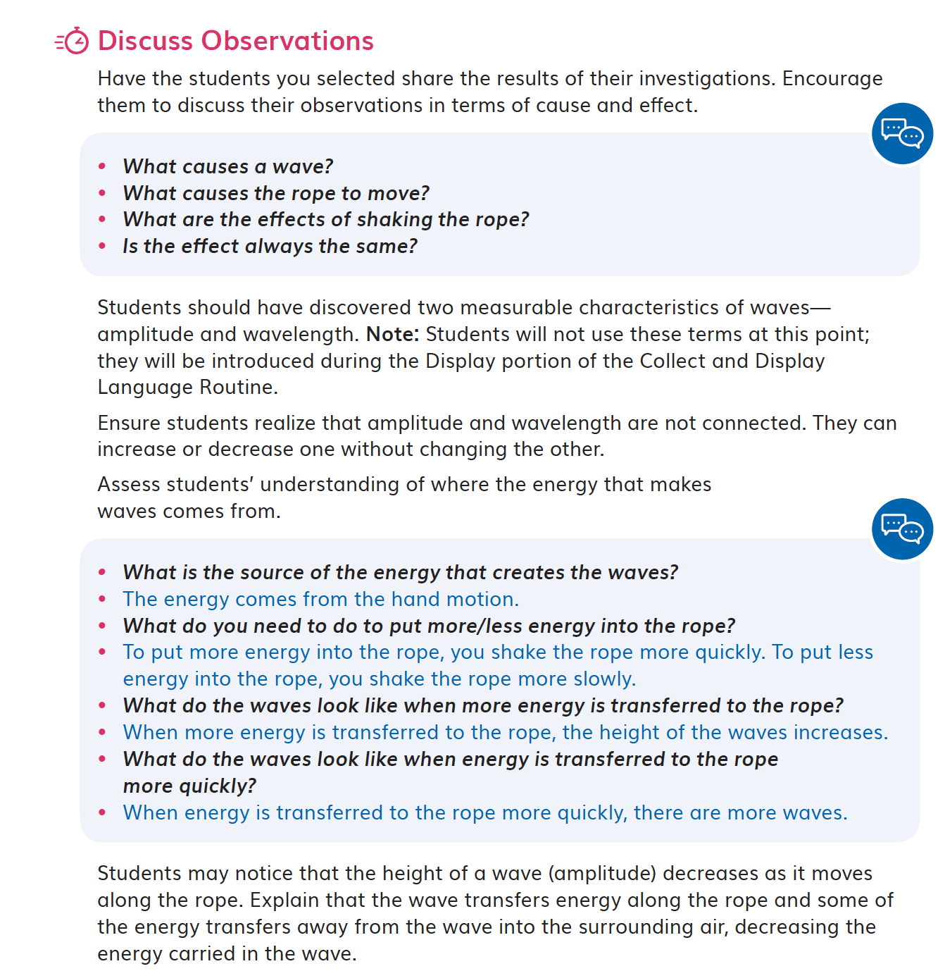  Grade 4 Module 4 DQ1L3 Report TE p. 25 | Describe the assessment (e.g., how many questions, presence of tables/charts, graphs). | Purpose of Assessment  (i.e., peer, self, formative, summative, per/post) | Type of Measure (e.g., performance task, discussion, multiple choice. constructed response) | Note evidence of bias or problems with accessibility.
 | As a whole class, students discuss their observations from the investigation in terms of the cause and effect of waves. | Self and peer | Discussion | No evidence of bias. All  students able to  offer up their  observations.
Match among Assessment, Phenomena/Problem, and Three Dimensions
What phenomenon or problem, if any, are students trying to figure out in this assessment? |  | What is the 2-3 dimensional learning goal assessed in this task?
Students are figuring out where the energy comes from that makes waves in the ropes, and how and why the size and frequency of waves change. |  | Students carry out an investigation (SEP-3), using CCC-1 and CCC-2, to understand the properties of waves—amplitude and wavelength (PS4.A).

Summative Performance Tasks

Assessment Description
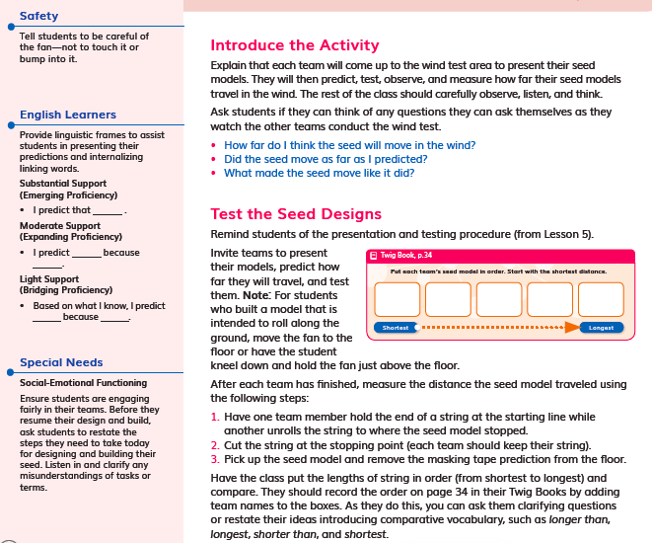  Grade 1 Module 1 DQ3L6 TE p. 114/DQ3L6 TB p. 34 | Describe the assessment (e.g., how many questions, presence of tables/charts, graphs). | Purpose of Assessment  (i.e., peer, self, formative, summative, per/post) | Type of Measure (e.g., performance task, discussion, multiple choice. constructed response) | Note evidence of bias or problems with accessibility.
 | In DQ3L1, DQ3L2, DQ3L4, DQ3L5 and DQ3L6 students work toward the Performance Task:  - L1—students compare different seeds  - L2—students gather information of how seeds disperse  - L4—students design a seed model that can be dispersed as far as possible by wind  - L5—students make a model seed  - L6—students test their seed models | Summative | Performance Task, hands-on | No evidence of bias. Suggestions are made as to how the teacher can modify the task for students with special needs and English Learners.
Match among Assessment, Phenomena/Problem, and Three Dimensions
What phenomenon or problem, if any, are students trying to figure out in this assessment? |  | What is the 2-3 dimensional learning goal assessed in this task?
Students are figuring out the phenomena of how the plants have different external parts that help them to survive and how parent plants have offspring, and are solving a design problem. |  | Students are assessed on how they gather information, and their ability to apply knowledge of seeds and seed dispersal to make and test a model seed.

Assessment Description
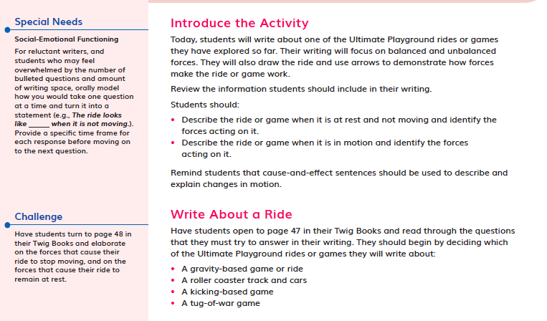  Grade 3 Module 1 DQ5L7 Investigate TE p. 278/DQ5L7 Investigate TB p. 89 | Describe the assessment (e.g., how many questions, presence of tables/charts, graphs). | Purpose of Assessment  (i.e., peer, self, formative, summative, per/post) | Type of Measure (e.g., performance task, discussion, multiple choice. constructed response) | Note evidence of bias or problems with accessibility.
 | Students develop model rides using a criteria and design. | Summative | Performance Task, hands-on | No evidence of bias
Match among Assessment, Phenomena/Problem, and Three Dimensions
What phenomenon or problem, if any, are students trying to figure out in this assessment? |  | What is the 2-3 dimensional learning goal assessed in this task?
Over the course of three lessons, students research, design, build, and test a magnetic ride. They figure out how magnetic interactions can create an amusement park ride that moves in fun and exciting ways. |  | Students are assessed on their ability to research, design, and build a dragon ride to test. They define criteria and constraints, and measure their success according to a rubric. They apply knowledge of forces and motion, non-contact forces, and generate solutions to an engineering problem (PS2.A, PS2.B, ETS1.B, ETS1.C, CCC-1, CCC-2, SEP-2, SEP-3, SEP-6).

Assessment Description
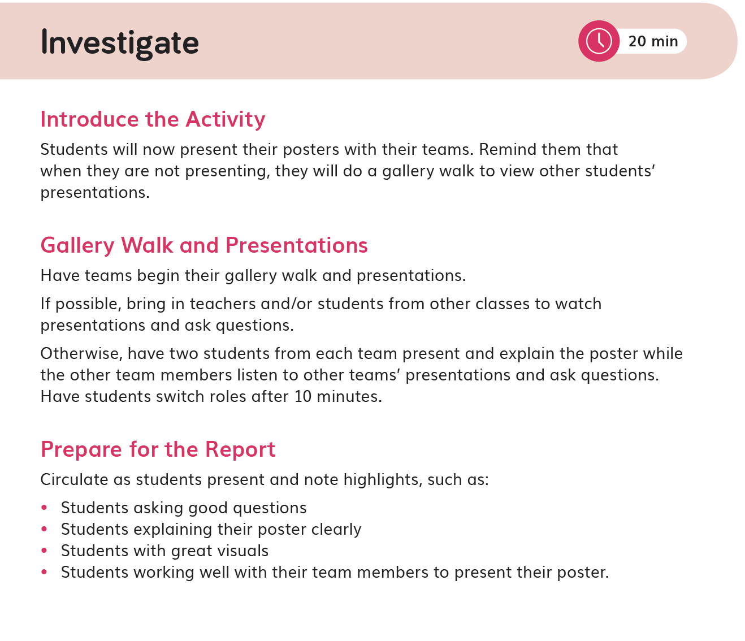Grade 4 Module 4 DQ6L5 TE p. 204/DQ6L5 TB pp. 100–101 | Describe the assessment (e.g., how many questions, presence of tables/charts, graphs). | Purpose of Assessment  (i.e., peer, self, formative, summative, per/post) | Type of Measure (e.g., performance task, discussion, multiple choice. constructed response) | Note evidence of bias or problems with accessibility.
 | Students complete the final stage of the Performance Task as they communicate information about the engineering  process in visual and oral presentations. | Self and summative | Performance Task, hands-on | Free from bias. All  students able to table part in this  Performance Task.
Match among Assessment, Phenomena/Problem, and Three Dimensions
What phenomenon or problem, if any, are students trying to figure out in this assessment? |  | What is the 2-3 dimensional learning goal assessed in this task?
Students have followed the engineering design process to investigate and solve the problem of how to reduce the damage caused by earthquakes. They have designed and built their own earthquake-resistant structure and tested it using a shake table. After analyzing the tests, they redesigned their structures and implemented improvements. Here, they communicate their designs in poster and presentation form. They use a rubric to self-assess their designs and posters, and their peers’. |  | To define a problem that includes specified criteria for success and constraints (3–5 ETS1-1), to generate and compare multiple solutions (3–5 ETS1-2), and then carry out tests to identify aspects of the design that can be improved (3–5 ETS1-3).

Summative Benchmark Assessment

Assessment Description
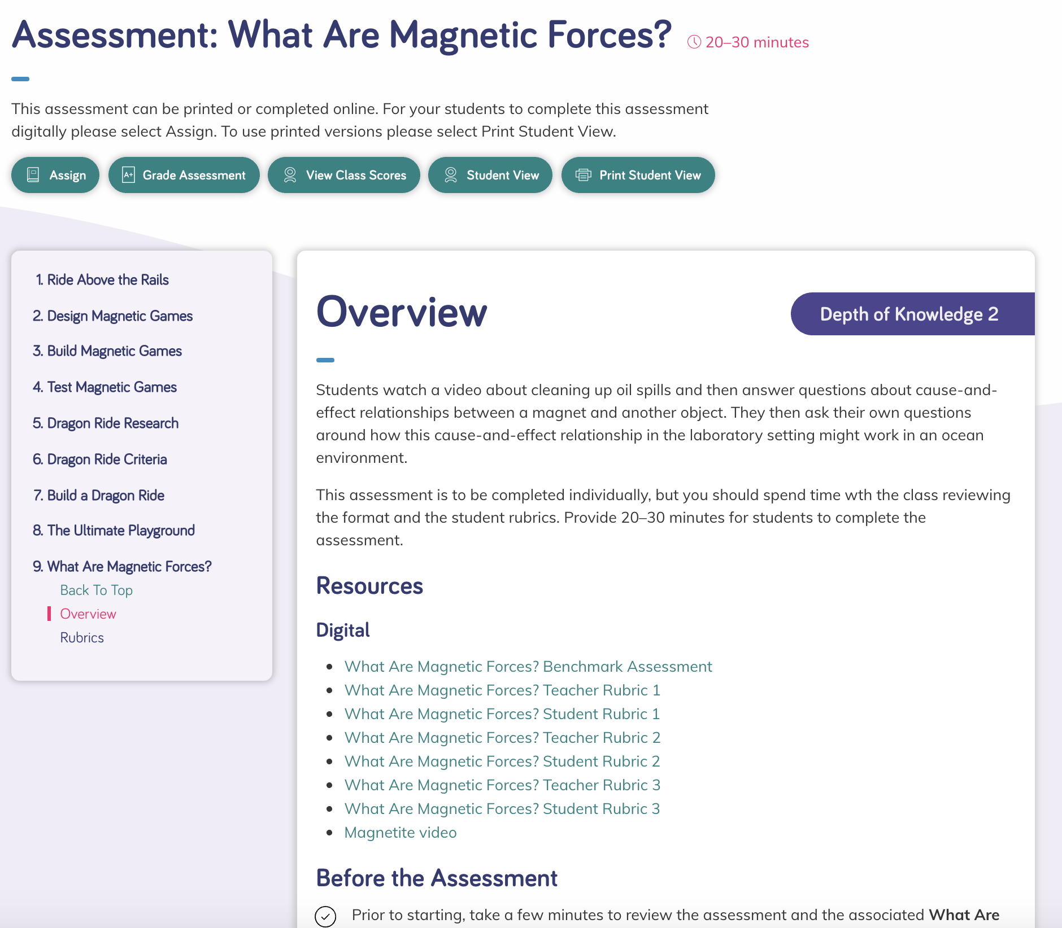Grade 3 Module 1 DQ5 What Are Magnetic Forces? Benchmark Assessment TE pp. 288–292 | Describe the assessment (e.g., how many questions, presence of tables/charts, graphs). | Purpose of Assessment  (i.e., peer, self, formative, summative, per/post) | Type of Measure (e.g., performance task, discussion, multiple choice. constructed response) | Note evidence of bias or problems with accessibility.
 | Students watch a video about cleaning up oil spills, and then answer questions about cause-and-effect relationships between a magnet and another object. They then ask their own questions around how this cause-and-effect relationship in the laboratory setting might work in an ocean environment. | Summative | Constructed response, written and drawn | No evidence of bias. Text-to-speech function available.
Match among Assessment, Phenomena/Problem, and Three Dimensions
What phenomenon or problem, if any, are students trying to figure out in this assessment? |  | What is the 2-3 dimensional learning goal assessed in this task?
Students are figuring out how non-contact forces, such as magnetism, can be used to solve engineering problems, such as cleaning up an oil spill. |  | Students are assessed on their ability to use what they have learned throughout the module to solve a real-world problem—cleaning up oil spills (PS2.B, SEP-2, SEP-6, CCC-2, ETS1.B).

Assessment Description
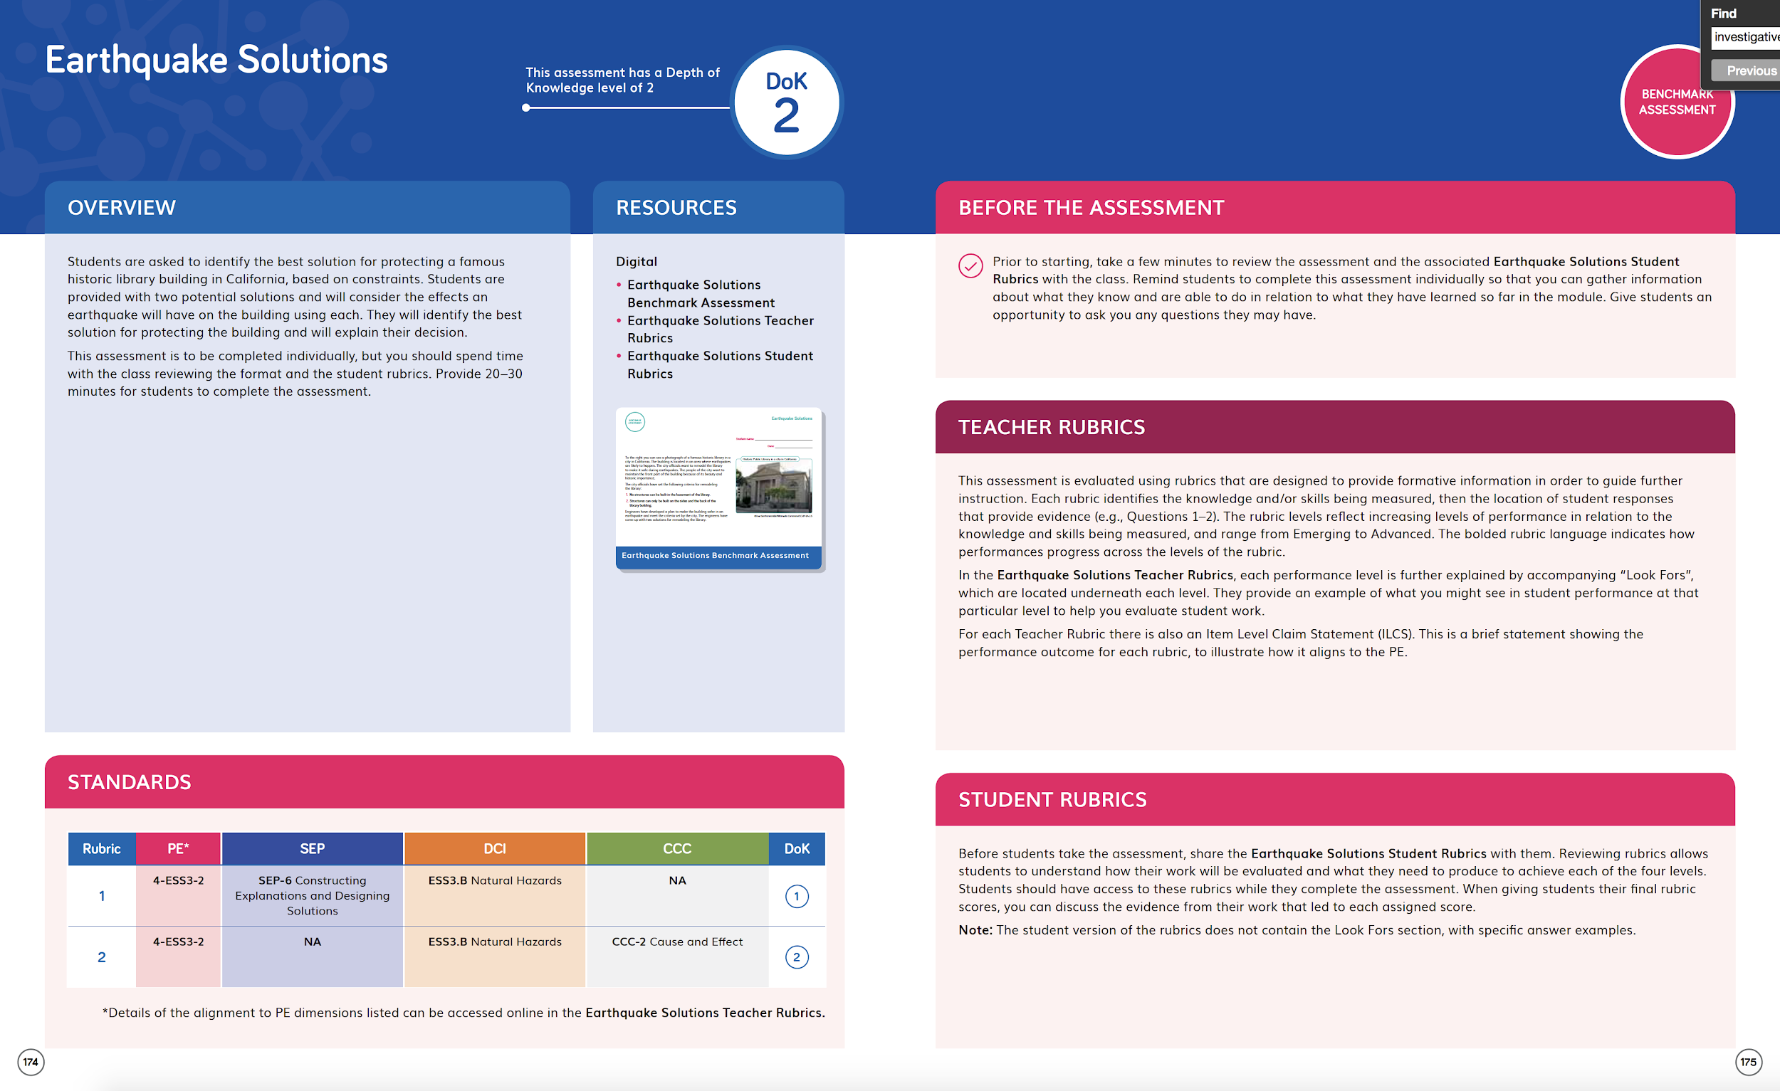Grade 4 Module 4 DQ2 Analyzing Maps Benchmark Assessment TE pp.88–91 | Describe the assessment (e.g., how many questions, presence of tables/charts, graphs). | Purpose of Assessment  (i.e., peer, self, formative, summative, per/post) | Type of Measure (e.g., performance task, discussion, multiple choice. constructed response) | Note evidence of bias or problems with accessibility.
 | Students analyze the data in a series of maps of California, showing the occurrence and magnitude of earthquakes.  They complete a series of scaffolded questions. | Summative | Performance Task, constructed response | No Bias. Text-to-speech function available for students that require language support.  Questions are scaffolded so all  students will be able to demonstrate their understanding.  Rubrics support teachers to  assess all levels of ability.
Match among Assessment, Phenomena/Problem, and Three Dimensions
What phenomenon or problem, if any, are students trying to figure out in this assessment? |  | What is the 2-3 dimensional learning goal assessed in this task?
Students take on the role of engineers to analyze earthquake data in maps to solve the problem of choosing the safest location to build a theme park in. |  | 4-ESS2-2 is assessed in this task. Students analyze data from maps to identify the locations and types of Earth's features on a map, and interpret data maps to identify patterns where earthquakes occur.

Summative 3-D Multiple Choice Assessment

Assessment Description
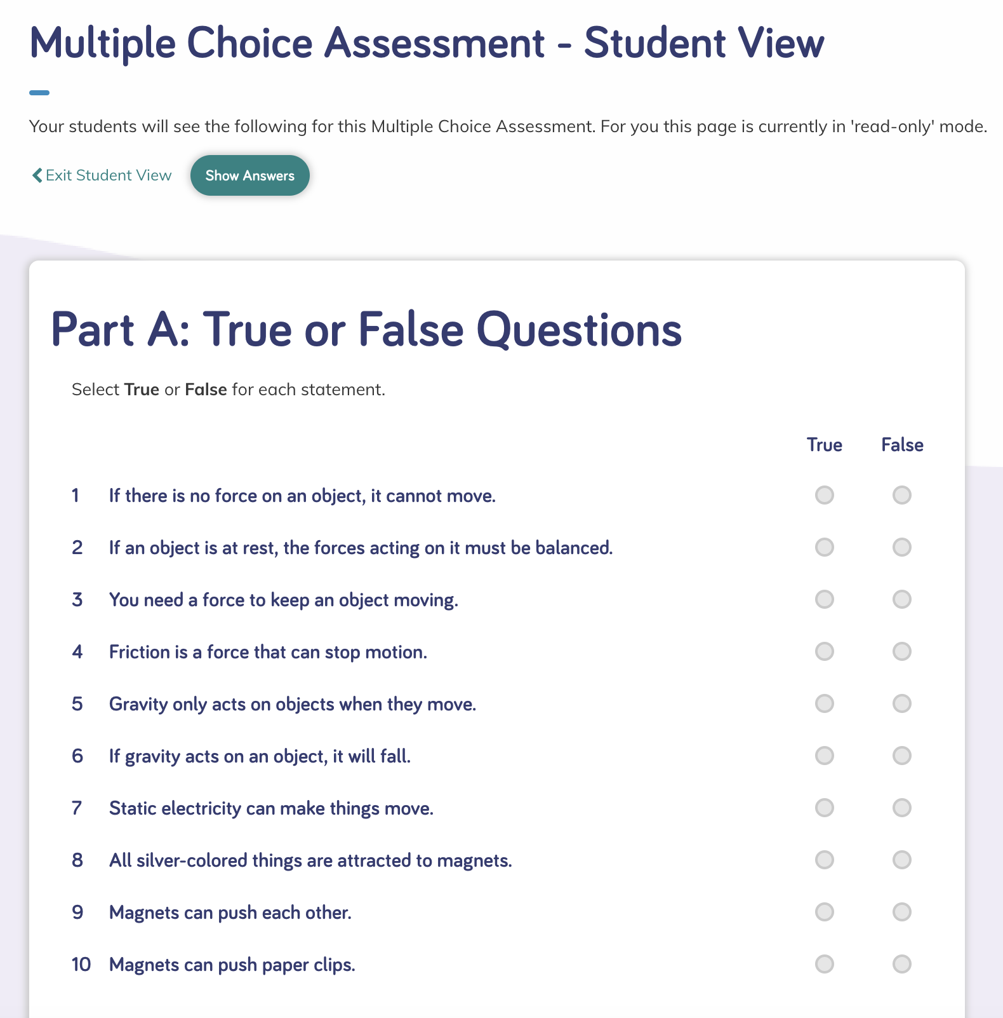  Grade 3 Module 1 Multiple Choice Assessment | Describe the assessment (e.g., how many questions, presence of tables/charts, graphs). | Purpose of Assessment  (i.e., peer, self, formative, summative, per/post) | Type of Measure (e.g., performance task, discussion, multiple choice. constructed response) | Note evidence of bias or problems with accessibility.
 | Part A: 10 True or False questions  Part B: 17 Multiple Choice questions  Part C: 5 Extended questions  Suggested pacing: 20–30 minutes | Summative | Multiple choice | No evidence of bias. A good mix of image-based and text questions, with text-to-speech function available.  Extended questions in Part C for GATE students.
Match among Assessment, Phenomena/Problem, and Three Dimensions
What phenomenon or problem, if any, are students trying to figure out in this assessment? |  | What is the 2-3 dimensional learning goal assessed in this task?
Students figure out the Module Phenomenon—How are objects affected by the forces of push and pull?—using a number of question types, and answering the DQs covered in the module. |  | Students are assessed on their ability to answer questions applying the SEPs, CCCs, DCIs, and engineering skills covered across the module.

Designed for the NGSS: Foundations | High Quality  5 | Medium Quality  3 | Low Quality  1
SP1: Three-dimensional Performances. Materials include assessments designed to:  - match the targeted learning goals, and,  - elicit observable evidence of students’ use of grade-appropriate elements of the three dimensions to make sense of phenomena and/or to design solutions to problems. | Materials include assessments that are consistently designed to connect to learning goals and require students to apply appropriate elements of the three dimensions to make sense of the phenomenon/ solve the problem. | Materials include assessments that are sometimes designed to connect to learning goals and require students to apply appropriate elements of the three dimensions to make sense of the phenomenon/solve the problem. | Materials include assessments that are designed such that they have limited connection to learning goals and/or they require students to apply elements of only one dimension to demonstrate their understanding of the phenomenon/solve the problem.
SP2: Variety of Measures. Assessments within a unit of instruction are matched to the targeted learning goals and elicit a full range of student thinking through:  - use of a variety of measures (e.g., performance tasks, discussion questions, constructed response questions, project- or problem- based tasks, portfolios, justified multiple choice); and  - multiple assessment opportunities so that students can demonstrate their understanding of the same learning goals in a variety of ways. | Materials include assessments that include a wide variety of formats with clear expectations that allow students to demonstrate their understanding of the learning goals in multiple ways. | Materials include assessments that include some variety of formats with clear expectations that allow students to demonstrate their understanding of the learning goals in multiple ways. | Materials include assessments that use just one format and/or the expectations for students to demonstrate their knowledge are absent or unclear.
SP3: Student Progress Over Time. The unit of instruction includes assessments that serve a variety of purposes (e.g., pre/post; formative, summative, peer, self) to measure students’ progress over time. The assessments:  - provide opportunities to see growth and development in the use of the dimensions over time; and,  - allow students to reflect on and monitor their sense-making/ problem-solving over time. | Materials include assessments that offer multiple opportunities, using more than one type of measure, to demonstrate learning and these measures are strongly connected to show student progress both in and across the three dimensions. | Materials include assessments that offer multiple opportunities, using more than one type of measure, to demonstrate learning and these measures are somewhat connected to show student progress in or across the three dimensions. | Materials include assessments that offer limited opportunities for students to demonstrate progress on the three dimensions.
SP4: Equitable Access. Assessments within the unit of instruction are designed to:  - be free from bias (e.g., gender, racial, socioeconomic status, cultural, etc.); and,  - be accessible to all students (e.g., reading level, accommodations). | Most assessments in the materials are free from bias and are accessible. | Some assessments in the materials are free from bias and are accessible. | Few assessments in the materials are free from bias and are accessible.

Designed for the NGSS: Student Progress Rubric
Analyze Evidence

Directions
  - Review the Designed for the NGSS: Student Progress Rubric.
  - Reflect on the evidence (or lack of evidence) that you and your team gathered.
  - Record strengths and limitations for each criterion based on your observations. Cite specific examples.

Strengths
SP1: Three-Dimensional Performances
The materials are High Quality 5 in regards to SP1
The Twig Science assessments are consistently designed to connect to learning goals and require students to apply appropriate elements of the three dimensions to make sense of the phenomenon/ solve the problem.
Evidence  All the assessments in Twig Science have been carefully designed to be multi-dimensional.  Students use the three dimensions to make sense of phenomena and solve problems. They articulate their reasoning and explanations through written and drawn explanations, discussions, and presentations.  Of particular note are the Summative Performance Tasks, which are present in all modules and wrap up instructional blocks, requiring students to demonstrate their ability to meet specific PEs. For example, in Grade 1 Module 1 (DQ3L6 Investigate TE p. 114), students meet the PEs 1-LS1-1, K–2-ETS1-2, and K–2-ETS1-3. They do this by comparing different seeds, gathering information of how seeds disperse, and solving the engineering design problem by designing, building, and testing their own a seed model that can be dispersed by the wind.  Every Module in Grades 3–6 also contains Benchmark Assessments, developed in partnership with the Stanford Center for Assessment, Learning, and Equity. Students are challenged to apply the skills and knowledge acquired in the module to new contexts. | 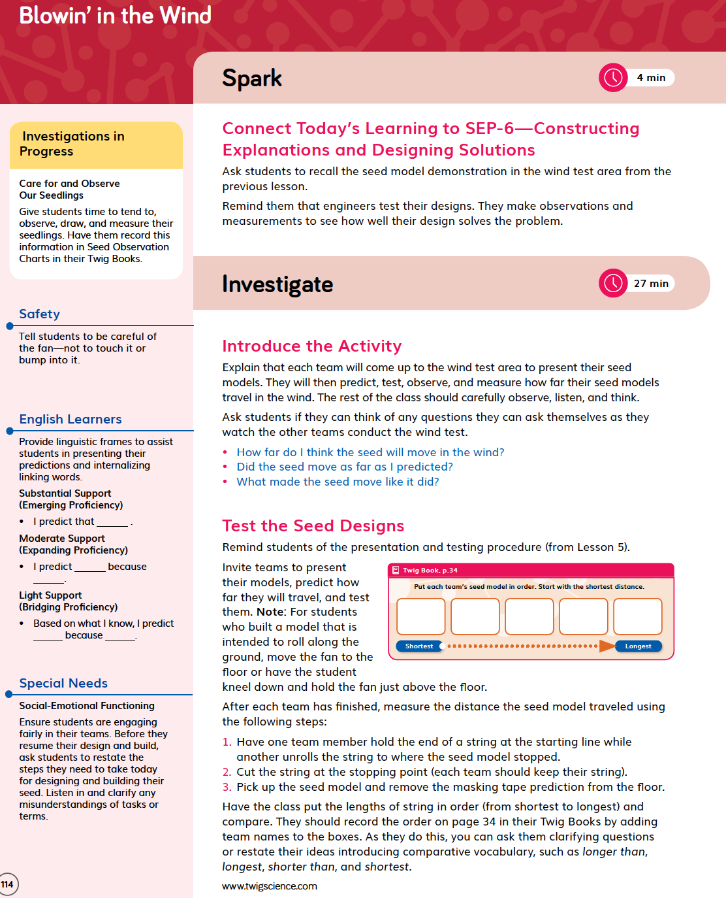Grade 1 Module 1 DQ3L6 Investigate TE p. 114
For example, in Grade 4 Module 4, students meet the PE ESS2-2. The Analyzing Maps Benchmark Assessment (DQ2 TE pp. 89–91, and online) requires students to take on the role of engineers to analyze earthquake data in maps and look for patterns helping them solve the problem of where to build a theme park that is at a low risk of damage from earthquakes. | 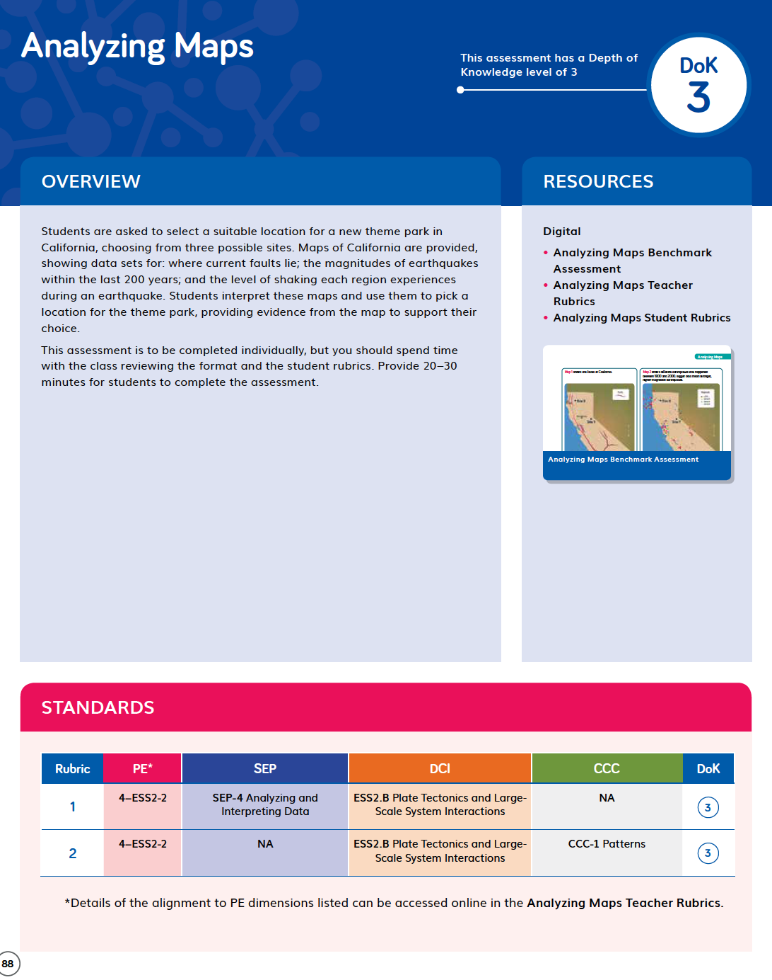  Grade 4 Module 4 DQ2 Analyzing Maps Benchmark Assessment TE p. 89
SP2: Variety of Measures
The materials are High Quality in regards to SP2
All modules include assessments in a wide variety of formats with clear expectations that allow students to demonstrate their understanding of the learning goals in multiple ways.
Evidence  Pre-Explorations (Diagnostic Pre-Assessments)  These pre-assessments include multiple choice and constructed responses (both written and drawn). For example, in Grade 3 Module 1 (DQ2L1 Reflect TE p. 119 / DQ2L1 Reflect TB p. 39). | Grade 3 Module 1 DQ2L1 Reflect TB p. 39
Formative Assessment (Informal Assessment)  Quick and easy informal assessments are embedded into all lessons. They are often found in the Reflect section of the lesson, and include a wide variety of formats. For example, in Grade 4 Module 4 Earthquake Engineering, following an investigation about waves in the ropes, students have a class discussion about where the energy comes from that makes the waves, and how and why the size and frequency of waves change (DQ1L3 Report TE p. 25).  Summative Performance Tasks  These highly engaging assessment tasks include written reports, posters, oral presentations, and collaborative engineering projects. For example, in Grade 4 Module 4, students have followed the engineering design process to solve the problem of how to reduce the damage caused by earthquakes. They have designed and built their own earthquake-resistant structures and tested them using a shake table. After analyzing the tests, they redesigned their structure with improvements. Here they communicate their designs in a poster and presentation. They use a rubric to self-assess their design and poster, as well as their peers’. | 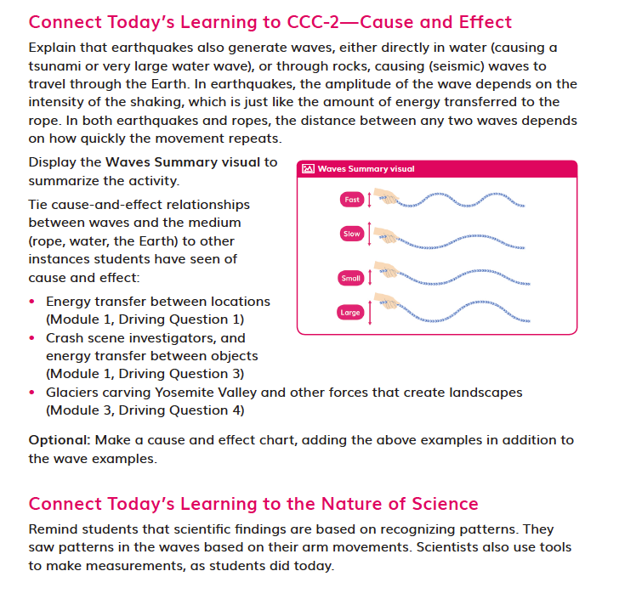  DQ1L3 Report TE p. 25
Benchmark Assessments  Designed to assess students’ ability to apply the three dimensions in a new context, the Benchmark Assessments include video and data analysis, hands-on activities, as well as design problems to solve. For example, in the Grade 3 Module 1 What Are Magnetic Forces? Benchmark Assessment, students are assessed on their ability to use what they have learned throughout the module about magnetism to solve a real-world problem. After watching a video about how magnets can clear up an oil spill in a small laboratory tank, they have to figure out how this cause-and-effect relationship in the laboratory setting might work in an ocean environment. | What Are Magnetic Forces? Benchmark Assessment
SP3: Student Progress Over Time
The materials are High Quality 5 in regards to SP3

All Twig modules include assessments that offer multiple opportunities—using more than one type of measure—to demonstrate learning, and these measures are strongly connected to show student progress both in and across the three dimensions.
Evidence  All modules contain diagnostic pre-assessments called Pre-Explorations at strategic points in the module that assess prior knowledge and enable teachers to identify misconceptions. Notes in the Teacher Edition and the Progress Tracker support teachers to track students' mastery of their misconceptions and the three dimensions throughout the module. Guidance is also given for how to tailor instruction for students whose misconceptions persist. For example, in Grade 4 Module 4, students complete a Pre-Exploration in DQ1L1 Reflect TB p. 19 and DQ3L1 Reflect TE p. 103.  A version of the Twig Book with sample answers is provided to support teachers to know what success looks like. A redux of this is also included at point of use in the Teacher Editions. | 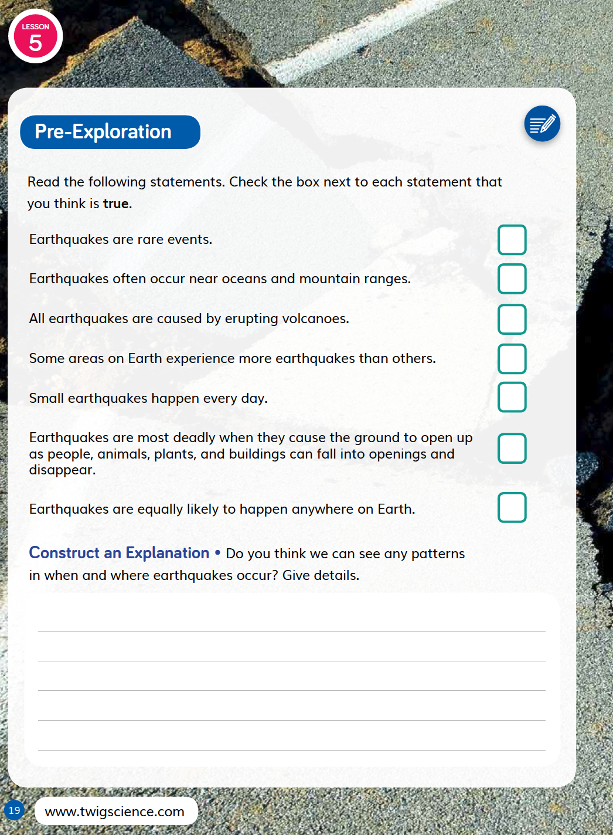  Grade 4 Module 4 DQ1L1 Reflect TB p. 19  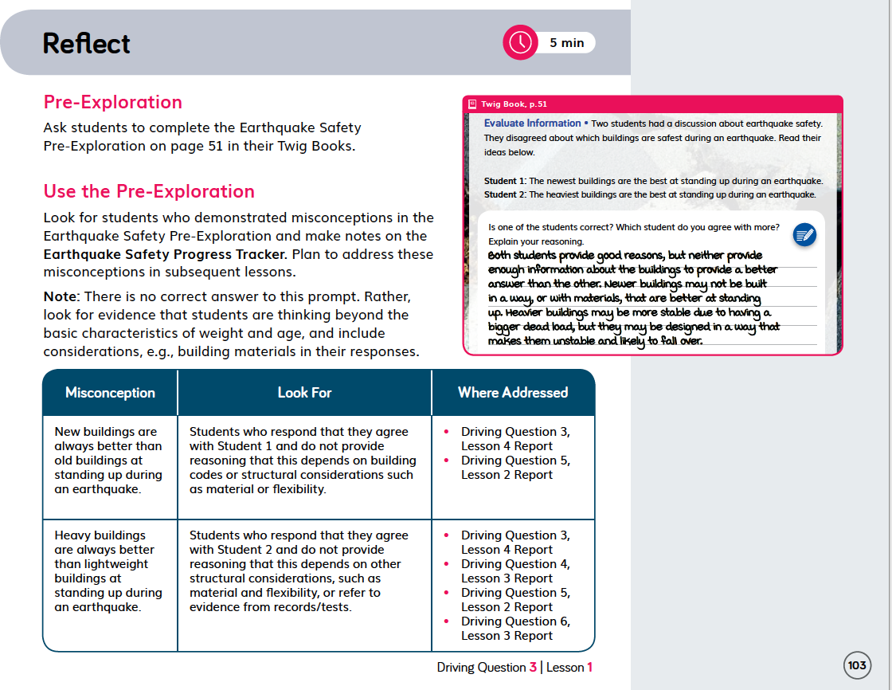  Grade 4 Module 4 DQ3L1 Reflect TE p. 103
Ongoing Formative Assessments are embedded in each module and provide frequent informal opportunities to quickly assess how students are progressing, using a variety of means. For example, in Grade 1 Module 1 (DQ4L4 TB p. 44), students connect images of young plants to images of how they will look as adult plants, and then to images of their parent plants. | Grade 1 Module 1 DQ4L4 TB p. 44
Performance Tasks, Benchmark Assessments, and Multiple Choice Assessments are tied to specific PEs. Data from these assessment items allow teachers to track student mastery of these PEs and their three dimension across the module and across the grade. | 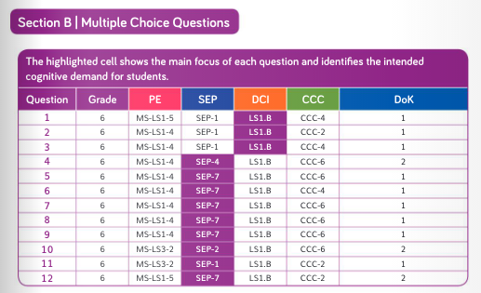  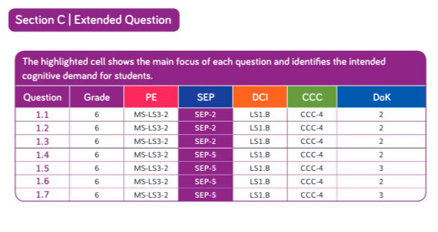Grade 6 Multiple Choice Assessment Section B and Data Alignment
SP4: Equitable Access
The materials are High Quality in regards to SP4
Assessments in all modules of Twig Science are free of bias and are accessible to all.
Evidence  The Twig Science Digital Twig Books and digital assessment items (Benchmark Assessments, Multiple Choice Assessments, and Student Rubrics) have a text-to-speech function, which allows students of all reading levels to access the assessments. | 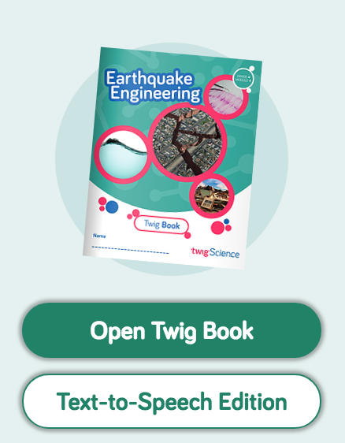  Digital Twig Books
Across all modules, assessments of the three dimensions are multimodal and include multiple choice, writing, drawing, physical models, posters, and oral presentations. This allows all students to access a range of assessment types to suit their learning style and/or reading level. | Constructed Response in Grade 3
Rubrics for the upper grade Performance Tasks and all Benchmark Assessments have four levels: Emerging, Developing, Proficient, and Advanced. This allows all students to demonstrate their current level of attainment. | 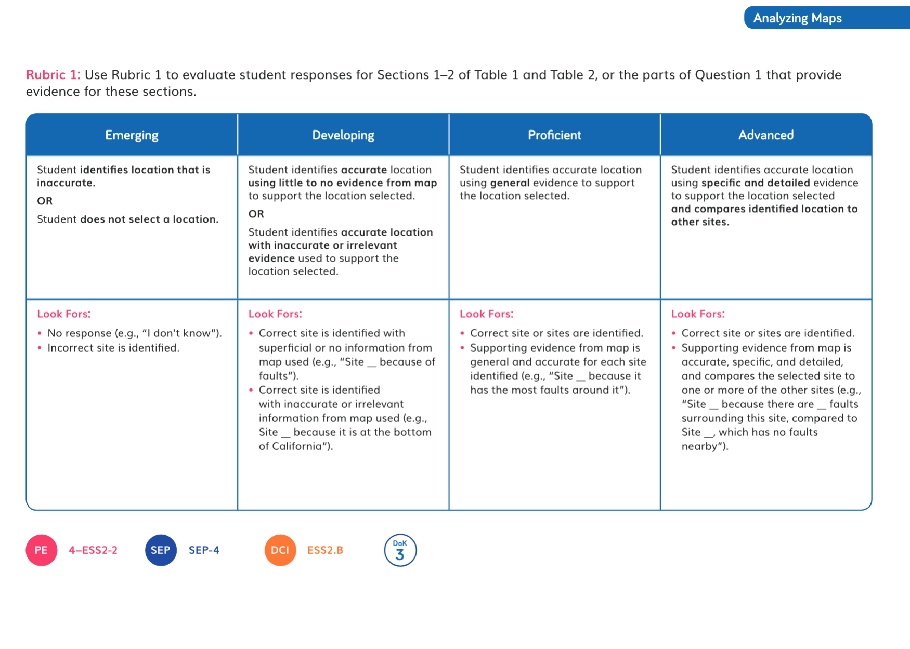  Leveled Rubric in Grade 4
The summative Benchmark and Multiple Choice Assessment targeting different DOK levels. Multiple Choice assessments contain an extended Part C to further challenge GATE students. | 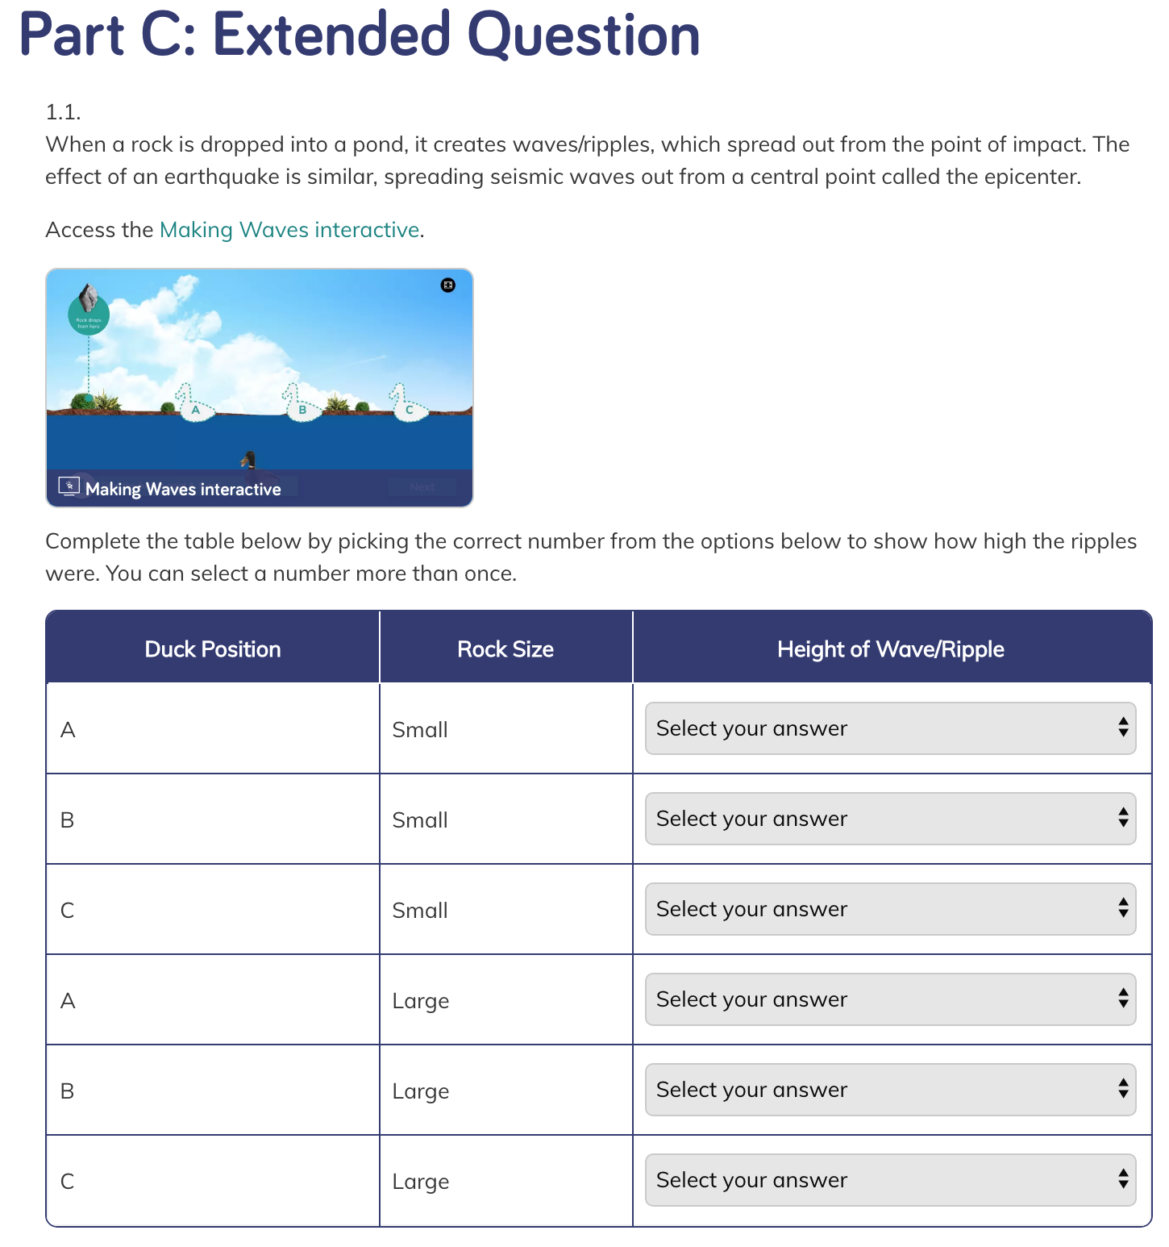Multiple Choice Assessment
Writing, Reading, Listening, and Speaking Domain tasks are dedicated to assessing science-relevant English language development, and are integrated into the core instructional resources and the Leveled Reader lessons in Chapter 3 Second Read. | 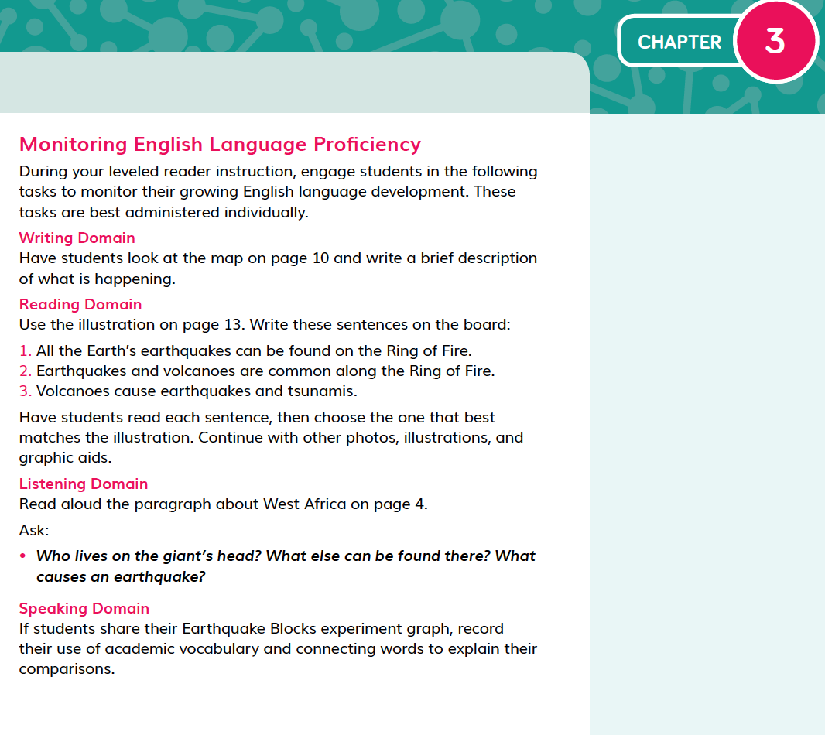Writing, Reading, Listening and Speaking Domain tasks in Grade 4

